Michael Weaver

CST – 235

Brandon Bass

11/26/17

**CLC 3**

GitHub Link: <https://github.com/battousairurik/CST-235>

**Question Answers**

1: JSF responds to user generated events by utilizing Event Listeners structured to catch the event source. For instance, when the user clicks the submit button on a webpage the event click is caught and then executed based upon the provided code. This can be as simple as redirecting the user to a new page, or sending their information through an authentication page for processing. More specifically; Command objects utilize action events, UI components utilize value change events, and the JSF processing life-cycle can utilize phase change events.

2: WebLogic

* An Oracle application server for building and deploying enterprise Java EE applications
* Oracle WebLogic Server 12c, the world’s first cloud-native, enterprise Java platform enables you to fully realize the benefits of cloud computing.
* Supports Databases for remote data storage with xhtml webpages

Glassfish

* the world's first implementation of the Java Platform, delivering a flexible, lightweight, and production-ready Java EE 6 application server.
* Oracle GlassFish Server is a robust open source platform that offers exhaustive and accessible documentation, intuitive administration and configuration features
* Supports Databases for remote data storage with xhtml webpages

**Assignment Approach**

1: To represent JSF response to user generated events I went ahead and designed a webpage that contains two buttons. Clicking one button causes an alert to pop up saying that oyu just triggered a user event. The second is a button that is meant to change color when it is selected, switching from grey with red text to red with black text. There is an included css style sheet that the project utilizes.

2: To represent a Glassfish server I decided to create two web pages and then create a command button that navigates from the first page to the second page, then vice versa. The idea was to represent the Glassfish ability to execute code. After attempting every possible method, using Implicit Navigation, Managed Bean, and even Redirection I was forced to give up because the webpage refuses to redirect.

**List of Classes, Methods, Variables, etc.**

1:

UserGeneratedEventsExample.xhtml

Style.css

2:

NavigationExample1.xhtml

NavigationExample2.xhtml

projectBeans\PageController.java (ManagedBean)

**Screenshots**

1:

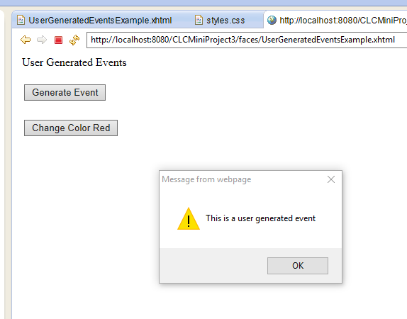

2.

